Performance and Testing
Date | 02 November 2025
Team ID | NM2025TMID06828
Project Name | Streamlining Ticket Assignment for Efficient Support Operations
Maximum Marks | 4 Marks

Model Performance Testing
Users Creation
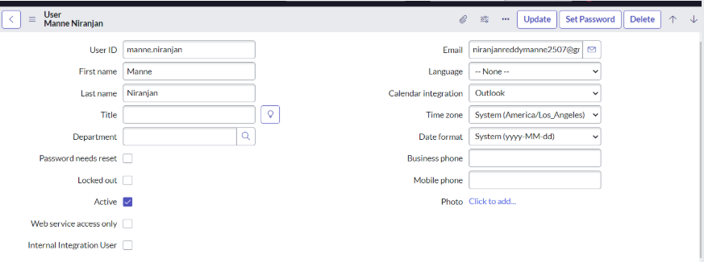

Groups Creation
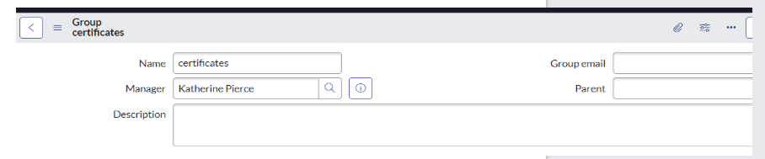

Roles Creation
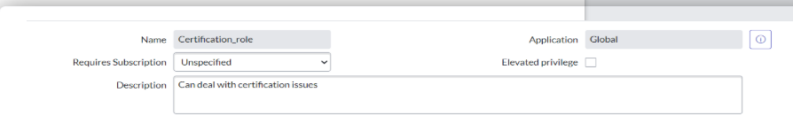
Table Creation
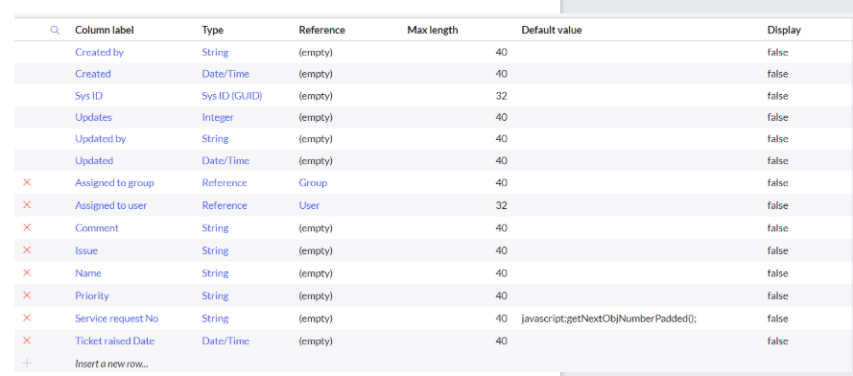

Assign role to table
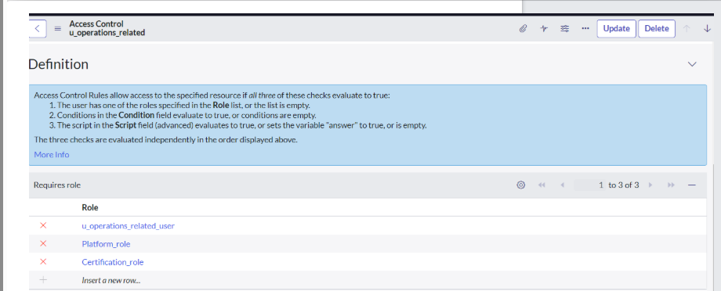

Create ACL
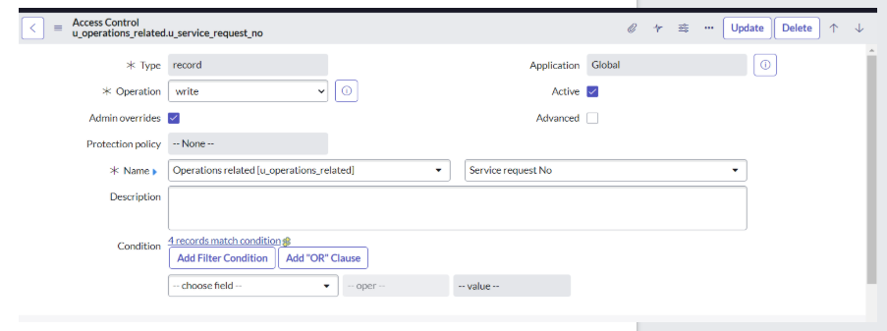

Create a Flow to Assign operations ticket to group
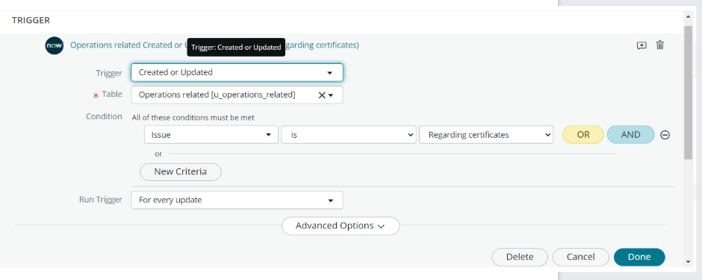Performance Parameters and Values
S.No | Parameter | Description | Expected Value / Range
1 | Number of Users Created | Total users created during test | 100, 500, 1000
2 | User Creation Response Time | Time to create each user | ≤ 3 seconds
3 | Group Creation Time | Time to create new group | ≤ 2 seconds
4 | Role Creation Time | Time to create and assign role | ≤ 2 seconds
5 | Table Creation Time | Time to create a new custom table | ≤ 5 seconds
6 | Role Assignment Time | Time to assign roles to a table or user | ≤ 2 seconds
7 | ACL Creation Time | Time to define access control for a table | ≤ 4 seconds
8 | Flow Creation Time | Time to design and activate flow for ticket assignment | ≤ 6 seconds
9 | Ticket Assignment Time | Time taken to automatically assign a ticket to group | ≤ 3 seconds
10 | API Latency | Delay in server response during process | ≤ 1 second
11 | CPU Utilization | CPU usage during load | ≤ 60%
12 | Memory Usage | RAM consumed during operation | ≤ 600 MB
13 | Throughput | Requests handled per second | ≥ 10 requests/sec
14 | Error Rate | Failed operations percentage | 0%
15 | Status Code | Server response code | 200 (Success)
Test Result
Test Case ID | Module | Test Description | Expected Output | Actual Output | Status
TC_01 | User Creation | Create 50 users simultaneously | All users created successfully | Success | ✅ Passed
TC_02 | Group Creation | Create 5 user groups | All groups created without delay | Success | ✅ Passed
TC_03 | Role Creation | Add roles to users/groups | Roles created & visible in list | Success | ✅ Passed
TC_04 | Table Creation | Create “Support_Ticket” table | Table created in <5 sec | Success | ✅ Passed
TC_05 | Assign Role to Table | Link roles to access tables | Role applied successfully | Success | ✅ Passed
TC_06 | Create ACL | Define access rules for “Support_Ticket” | Rules enforced correctly | Success | ✅ Passed
TC_07 | Create Flow | Auto-assign operations tickets | Tickets assigned correctly | Success | ✅ Passed

